Idris Ratlamwala

C31 - 2003145

Experiment 10: Program on user defined exception

**Theory :**

The predefined exceptions are used to handle errors occurring in the program.

But sometimes the programmer wants to create his own customized exception as per the requirements of the application which is called **user-defined exception** or custom exception.

Custom exceptions in Java are those exceptions that are created by a programmer to meet the specific requirements of the application. That’s why it is also known as user-defined exception in Java.

**For example:**

1. A banking application, a customer whose age is lower than 18 years, the program throws a custom exception indicating “needs to open joint account”.

2. Voting age in India: If a person’s age entered is less than 18 years, the program throws “invalid age” as a custom exception.

**Syntax:**

We do not have any particular syntax for Java user-defined exception,

Below is the code which will help to Create a User-defined exception class,

class SampleException{  
public static void main(String args[]){  
try{  
throw new UserException(<value>); // used to create new exception and throw  
}  
catch(Exception e){  
System.out.println(e);  
}  
}  
}  
class UserException extends Exception{  
// code for exception class  
}

Here, while creating an exception class, it needs to be extended from java. lang.Exception.

An exception is an event that leads to sudden termination of the program during execution at runtime.

**A.**

**Aim :** WAP to accept any integer from the user & if the entered number is not any of 5 or 6 or 7 then create an exception & catch it.

**Program :**

    import java.util.*;

    class MyException extends Exception {

        MyException(String s) {

            super(s);

        }

    }

    public class InvalidNumExcep {

        static void check(int num) throws MyException {

            if (num != 5 && num != 6 && num != 7) {

                throw new MyException("Invalid input");

            }

        }

        public static void main(String[] args) {

            Scanner sc = new Scanner(System.in);

            try {

                System.out.print("Enter a number : ");

                int num = sc.nextInt();

                check(num);

                System.out.println("Valid input");

            } catch (Exception e) {

                System.out.println(e);

            }

            sc.close();

        }

    }

**Output :**

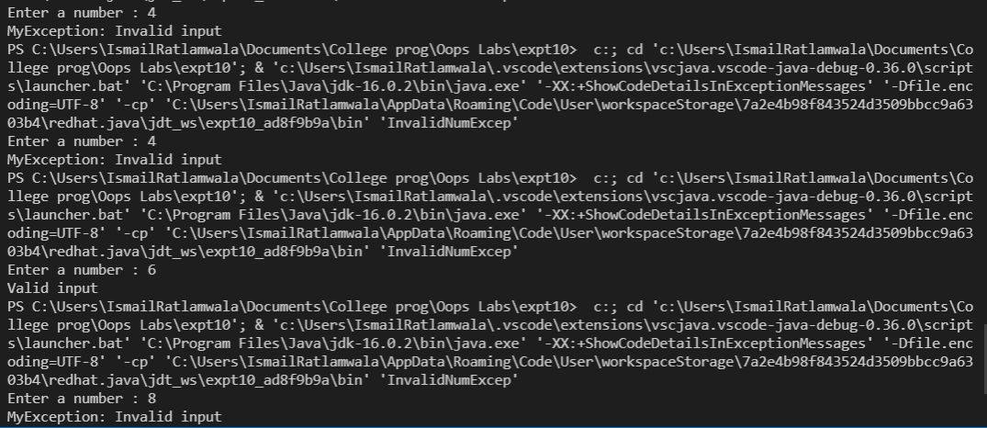

**B.**

**Aim :** WAP to create an exception ‘PayOutOfBounds’ when the basic pay paid to

the Superintendent it is less than 25,000 and greater than 50,000.

**Program :**

    import java.util.Scanner;

    class PayOutOfBoundsException extends Exception{

        PayOutOfBoundsException(String s){

            super(s);

        }

    }

    public class PayOutOfBounds {

        static void basicPayCheck(int salary)throws PayOutOfBoundsException{

            if(salary<25000 || salary>50000){

                throw new PayOutOfBoundsException("Pay "+salary+"out ofbounds");

            }

        }

        public static void main(String[] args) {

            Scanner sc = new Scanner(System.in);

            System.out.print("Enter basic pay :");

            int salary= sc.nextInt();

            try{

                basicPayCheck(salary);

                System.out.println("Basic pay is valid");

            }

            catch(Exception e){

                System.out.println(e);

            }

            sc.close();

        }

    }

**Output** :

